Equipment Inventory Data Analysis

Submitted on August 30, 2023

[Shareable Link](https://www.coursera.org/learn/excel-basics-data-analysis-ibm/peer/sac00/final-assignment-part-3-submit-your-work-and-peer-review/review/cQpzZkeaEe6fzxL26Xh33w)

**PROMPT**

Upload the completed Excel file named **Montgomery_Fleet_Equipment_Inventory_FA_PART_1_END.XLSX** that you saved in Task 8 in Part 1 of the final assignment.

Equipment Inventory Analysis Part1

[Equipment Inventory Analysis Part1](https://coursera-assessments.s3.amazonaws.com/assessments/1693443442421/141f97ee-8153-4e69-ad54-f4591cbb2800/Montgomery_Fleet_Equipment_Inventory_FA_PART_1_START.xlsx)

Analyzing different departments with regarding to their class and Equipment count

**RUBRIC**

Has the learner uploaded the completed Excel file named **Montgomery_Fleet_Equipment_Inventory_FA_PART_1_END.XLSX** for Part 1 of the final assignment, and can you open it using Excel?

|  | 0 points  No file has been uploaded. |  |
| --- | --- | --- |
|  | 1 point  The file has been successfully uploaded with an XLSX extension (i.e. not a CSV file) but cannot be opened in Excel. |  |
|  | **2 points**  **The file has been successfully uploaded with an XLSX extension (i.e. not a CSV file) and can be opened in Excel.** | BM |

**PROMPT**

Part 1 Task 3: Have you used the Filter feature to look for blanks and remove all empty rows from the data? Yes/No

Yes

**RUBRIC**

Refer to the Excel worksheet uploaded by the learner in Prompt 1. Have all the empty rows been removed from the data? There should be 53 rows of data in the workbook (54 rows including the header).

|  | 0 points  None of the empty rows have been removed from the data. |  |
| --- | --- | --- |
|  | 1 point  Some of the empty rows have been removed from the data. |  |
|  | **2 points**  **All the empty rows have been removed from the data.** | BM |

**PROMPT**

Part 1 Task 4: Have you used either the Conditional Formatting or Remove Duplicates feature to look for and remove any duplicated records from the data? Yes/No

Yes

**RUBRIC**

Refer to the Excel worksheet uploaded by the learner in Prompt 1. Has the learner used either the Conditional Formatting or Remove Duplicates feature to look for and remove any duplicated records from the data?

|  | 0 points  None of the duplicated records have been removed from the data. |  |
| --- | --- | --- |
|  | 1 point  Some of the duplicated records have been removed from the data. |  |
|  | **2 points**  **All the duplicated records have been removed from the data.** | BM |

**PROMPT**

Part 1 Task 5: Have you checked for spelling mistakes in the data and fixed them? Yes/No

Yes

**RUBRIC**

Refer to the Excel worksheet uploaded by the learner in Prompt 1. Have all the spelling mistakes in the data been fixed?

|  | 0 points  None of the spelling mistakes have been fixed in the data. |  |
| --- | --- | --- |
|  | 1 point  Some of the spelling mistakes have been fixed in the data. |  |
|  | **2 points**  **All the spelling mistakes have been fixed in the data.** | BM |

**PROMPT**

Part 1 Task 6: Have you used the Find and Replace feature to remove all double-spaces from the data? Yes/No

Yes

**RUBRIC**

Refer to the Excel worksheet uploaded by the learner in Prompt 1. Have all the double spaces in the data been removed?

|  | 0 points  None of the double spaces in the data have been removed. |  |
| --- | --- | --- |
|  | 1 point  Some of the double spaces in the data have been removed. |  |
|  | **2 points**  **All of the double spaces in the data have been removed.** | BM |

**PROMPT**

Part 1 Task 7: Have you used Flash Fill to reduce the department names to just one column, and then removed any unnecessary columns? Yes/No

Yes

**RUBRIC**

Refer to the Excel worksheet uploaded by the learner in Prompt 1. Are all the department names in a single column? Have the unnecessary columns been removed?

|  | 0 points  None of the department names are in a single column. None of the unnecessary columns have been removed. |  |
| --- | --- | --- |
|  | 1 point  Some of the department names are in a single column, but none of the unnecessary columns have been removed. |  |
|  | 2 points  Some of the department names are in a single column, and some or all of the unnecessary columns have been removed. |  |
|  | 2 points  All of the department names are in a single column, but none or some of the unnecessary columns have been removed. |  |
|  | **3 points**  **All of the department names are in a single column, and all of the unnecessary columns have been removed.** | BM |

**PROMPT**

Part 1 Task 2: Have you widened all columns so that all the data is visible? Yes/No

Yes

**RUBRIC**

Refer to the Excel worksheet uploaded by the learner in Prompt 1. Have all the columns been widened to display all the data?

|  | 0 points  None of the columns have been widened to display all the data. |  |
| --- | --- | --- |
|  | **1 point**  **All of the columns have been widened to display all the data.** | BM |

**PROMPT**

Upload the completed Excel file named **Montgomery_Fleet_Equipment_Inventory_FA_PART_2_END.XLSX** that you saved in Task 7 in Part 2 of the final assignment.

Equipment Inventory Analysis Part 2

[Equipment Inventory Analysis Part 2](https://coursera-assessments.s3.amazonaws.com/assessments/1693442867315/a8ae9891-b354-478a-a5ec-9951993b2872/Montgomery_Fleet_Equipment_Inventory_FA_PART_2_START.xlsx)

Created Pivot tables using the given data and used autosum to find sum, average, Min, Max, and count.

**RUBRIC**

Has the learner uploaded the completed Excel file named **Montgomery_Fleet_Equipment_Inventory_FA_PART_2_END.XLSX** for Part 2 of the final assignment, and can you open it using Excel?

|  | 0 points  No file has been uploaded. |  |
| --- | --- | --- |
|  | 1 point  The file has been successfully uploaded, but with a different filename, and it can be opened in Excel. |  |
|  | 1 point  The file has been successfully uploaded with the correct filename, but it cannot be opened in Excel. |  |
|  | **2 points**  **The file has been successfully uploaded with the correct filename and it can be opened in Excel.** | BM |

**PROMPT**

Part 2 Task 1: Have you used the Format as Table option to format the data as a table? Yes/No

Yes

**RUBRIC**

Refer to the Excel worksheet uploaded by the learner in Prompt 8. Has the data been formatted as a table, similar to the image below? (the style colors used are not important)

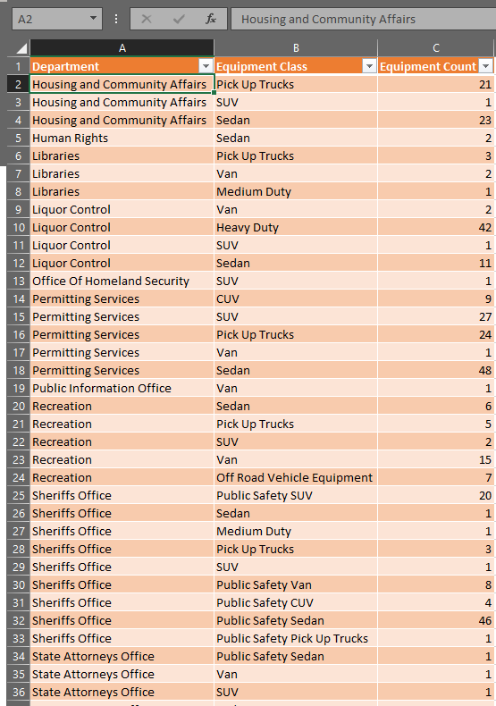

|  | 0 points  The data has not been formatted as a table. |  |
| --- | --- | --- |
|  | **1 point**  **The data has been successfully formatted as a table.** | BM |

**PROMPT**

Part 2 Task 2: Have you used AutoSum to find the following values for column C and recorded each of the values? Record the five values below.

SUM

AVERAGE

MIN

MAX

COUNT

SUM = 1582

AVERAGE = 32.28571439

MIN = 1

MAX = 139

COUNT = 49

**RUBRIC**

Refer to the Excel worksheet uploaded by the learner in Prompt 8. Have each of the following values been recorded correctly?

SUM = **1582**

AVERAGE = **32.28571429**

MIN = **1**

MAX = **379**

COUNT = **49**

|  | 0 points  None of the values have been recorded correctly. |  |
| --- | --- | --- |
|  | 1 point  Between 1 and 3 of the values have been recorded correctly. |  |
|  | **2 points**  **4 or 5 of the values have been recorded correctly.** | BM |

**PROMPT**

Part 2 Task 3: Have you used the PivotTable feature to create a pivot table that displays the Department field in the Rows section, and the Equipment Count in the Values section, so that the pivot table displays the sum of equipment count by department? Yes/No

Yes

**RUBRIC**

Refer to the Excel worksheet uploaded by the learner in Prompt 8. Has the correct pivot table been created? (The pivot table should look like the one below)

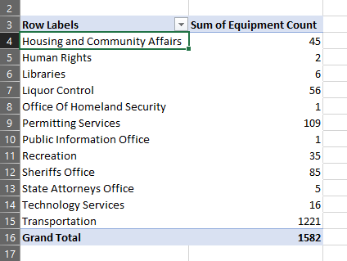

|  | 0 points  The pivot table has not been created. |  |
| --- | --- | --- |
|  | 1 point  There is a pivot table, but it is not the correct one. |  |
|  | **2 points**  **The correct pivot table has been created.** | BM |

**PROMPT**

Part 2 Task 4: Have you used the ‘Sort By Value’ setting on the pivot table to sort it in descending order by the sum of equipment count? Yes/No

Yes

**RUBRIC**

Refer to the Excel worksheet uploaded by the learner in Prompt 8. Has the pivot table been sorted correctly by the sum of equipment count? (The table should look like the one below)

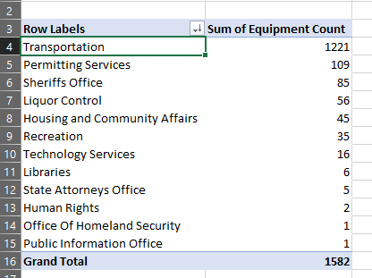

|  | 0 points  The pivot table has not been sorted correctly. |  |
| --- | --- | --- |
|  | **1 point**  **The pivot table has been sorted correctly.** | BM |

**PROMPT**

Part 2 Task 5: Have you followed the same steps you performed in Part 2 - Tasks 3 and 4 to create two more identical pivot tables so that you end up with 3 worksheets that contain identical pivot tables? Yes/No

Yes

**RUBRIC**

Refer to the Excel worksheet uploaded by the learner in Prompt 8. Have two additional pivot tables, identical to the one created in the previous prompt, been created, meaning there are now three identical pivot tables on three separate worksheets?

|  | 0 points  No additional identical pivot tables have been created. |  |
| --- | --- | --- |
|  | 1 point  1 of the additional identical pivot tables has been created. |  |
|  | **2 points**  **Two additional identical pivot tables have been created.** | BM |

**PROMPT**

Part 2 Task 6a: Have you used the PivotTable Fields pane to manipulate and analyze data in pivot table 2? In pivot table 2 have you added the Equipment Class field below the Department field so that the different vehicle types appear under each department with their respective counts? Have you collapsed all fields except the top one - **Transportation**? Yes/No

Yes

**RUBRIC**

Refer to the Excel worksheet uploaded by the learner in Prompt 8. In pivot table 2 is the Equipment Class field below the Department field so that the different departments appear first, with the different vehicle types listed under each department with their respective counts? Have all the fields been collapsed except the top one - **Transportation**? (The pivot table and the PivotTable Fields pane should look like the images below).

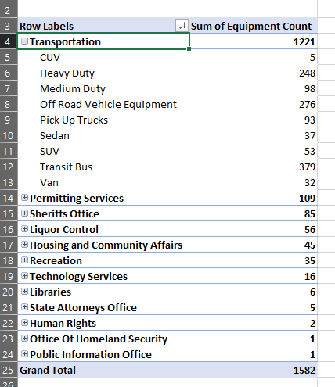

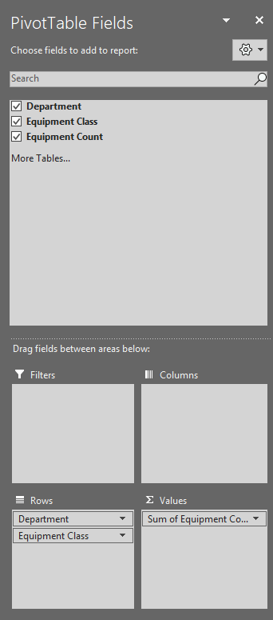

|  | 0 points  The Equipment Class field has not been added below the Department field and is not listed in the PivotTable Fields pane at all. |  |
| --- | --- | --- |
|  | 1 point  The Equipment Class field has not been added below the Department field, but it is in the PivotTable Fields pane in the wrong section. |  |
|  | 1 point  A different field has been added below the Department field and is listed in the PivotTable Fields pane. |  |
|  | 1 point  The Equipment Class field has been added below the Department field so that the different vehicle types appear under each department with their respective counts. |  |
|  | **2 points**  **The Equipment Class field has been added below the Department field so that the different vehicle types appear under each department with their respective counts. Also, all the fields have been collapsed except Transportation.** | BM |

**PROMPT**

Part 2 Task 6b: Have you used the PivotTable Fields pane to manipulate and analyze data in pivot table 3? In pivot table 3 have you added the Equipment Class field above the Department field so that the different vehicle types appear first, with the different departments listed underneath each vehicle type with their respective counts? Have you collapsed all fields except the top one - **CUV**? Yes/No

Yes

**RUBRIC**

Refer to the Excel worksheet uploaded by the learner in Prompt 8. In pivot table 3 is the Equipment Class field above the Department field so that the different vehicle types appear first, with the different departments listed underneath each vehicle type with their respective counts? Have all the fields been collapsed except the top one - **CUV**? (The pivot table and the PivotTable Fields pane should look like the images below).

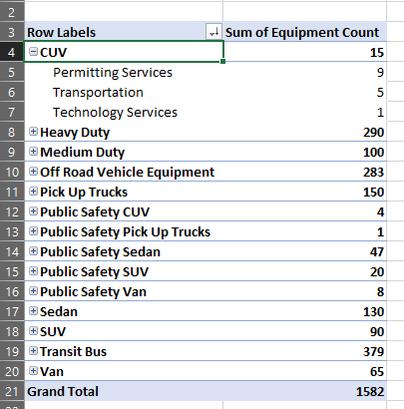

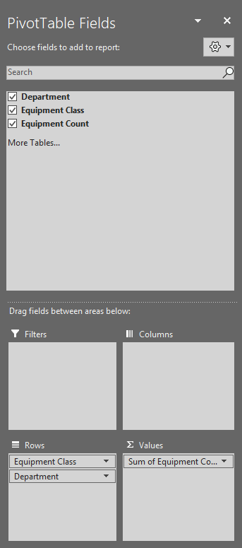

|  | 0 points  The Equipment Class field has not been added above the Department field and is not listed in the PivotTable Fields pane at all. |  |
| --- | --- | --- |
|  | 1 point  The Equipment Class field has not been added above the Department field, but it is in the PivotTable Fields pane in the wrong section. |  |
|  | 1 point  A different field has been added above the Department field and is listed in the PivotTable Fields pane. |  |
|  | 1 point  The Equipment Class field has been added above the Department field so that the different departments appear under each vehicle type with their respective counts. |  |
|  | **2 points**  **The Equipment Class field has been added above the Department field so that the different departments appear under each vehicle type with their respective counts. Also, all the fields have been collapsed except CUV.** | BM |

Start new attempt

### Comments

Comments left for the learner are visible only to that learner and the person who left the comment.

AR